Enterprise Electronic Document Management System
Functional & Business Design Specification

Document Details
Control, ownership and approval information

Document Control
Document Owner | To be confirmed
Business Owner | To be confirmed
Classification | Internal / Controlled
Approval Status | Pending approval

Revision History
Version | Date | Description | Author
0.1 | To be confirmed | Initial controlled draft | To be confirmed

Review and Approval
Role | Name | Signature | Date
Reviewed by | To be confirmed
Approved by | To be confirmed

Document type | Functional & Business Design (Solution Definition)
Client / Owner | Client, UAE
Platform | Microsoft Azure · Microsoft 365 · SharePoint Online · Entra ID · UAE PASS
Version | 2.1 (multi-level review chain)
Status | Draft for Review
Classification | OFFICIAL – Client Internal Use
Date | 4 September 2026

Table of Contents
Document Control 1
Revision History 1
Review and Approval 1
1. Executive Summary 7
1.1 Business Value for the Client 7
1.2 Scope of this Document 7
2. Business Context & Objectives 8
2.1 The Problem Today 8
2.2 Objectives 8
2.3 Alignment to UAE Government Standards 8
3. Personas & Role Model 9
3.1 Personas 9
3.2 Role Hierarchy (RBAC + ABAC) 9
4. Solution Capability Overview 10
5. The Docaya Document Lifecycle - Revised End-to-End Flow 12
5.1 Status State Machine 14
6. Module M1 Capture & Document Registration 15
6.1 Functional Design 15
6.2 Auto-Populated vs. User-Entered Fields 15
7. Module M2 Classification & Metadata 16
7.1 Classification Dimensions 16
7.2 Manual Classification Controls 16
8. Module M3 Workflow & Approval 17
8.1 Submission & Routing 17
8.2 Approval Patterns 17
8.3 Decision Handling 17
8.4 Configurable multi-level review chain 17
8.5 Threaded comments & actions 18
8.6 Change-request SLA & timeline engine 18
9. Module M4 Promotion & Publishing 19
10. Module M5 Staging Lifecycle & Cleanup 19
11. Module M6 Upload Text Extraction & Search Data 21
11.1 Pipeline Stages 21
11.2 Design Principles 21
12. Module M7 Notification Center 22
13. Module M8 Correspondence Management 24
14. Module M9 Records, Retention & Legal Hold 24
15. Module M10 Search & Discovery 24
15.1 Department / standard navigation 24
15.2 One-click access 24
15.3 Extended filters 25
16. Module M11 Identity, SSO & SharePoint Integration 26
16.1 Single Sign-On with UAE PASS 26
16.2 Governed SharePoint Service Identity 26
17. Module M12 Access Control (RBAC + ABAC) 26
18. Module M13 Admin Center 26
19. Module M14 - Existing Document Modification 28
20. Module M15 - Analytics 28
20.1 Reporting & Power BI Architecture 28
20.2 Metadata & Classification Reports 28
20.3 Workflow & Change-Request Reports 28
20.4 Audit & Compliance Reports 29
20.5 Standard Reports Library & Export 29
21. Module M16 - Audit & Compliance 29
21.1 Full audit trail & version history 30
22. Reference Architecture 31
22.1 Solution Architecture - Azure & Microsoft Building Blocks 31
22.2 Application Architecture - Component View 32
23. Non-Functional & Compliance Targets 34
24. Delivery Roadmap 34
25. Assumptions, Decisions & Next Steps 34
25.1 Key Design Decisions 34
25.2 Immediate Next Steps 35

1. Executive Summary
Docaya is an enterprise electronic document management system built for the Client on Microsoft Azure, Microsoft 365 and SharePoint Online, with UAE PASS federated to Microsoft Entra ID as the primary single sign-on. It replaces uncontrolled shared drives and email-based approvals with one governed lifecycle in which every document is captured, classified, reviewed, approved, published and retained under a single auditable trail.
The design centres on a governed document lifecycle (Section 5) delivered by sixteen functional modules, M1–M16 (Section 4). During upload, the original supported file and its extracted basic machine-readable text, technical metadata and preview data are held in staging. Business classification metadata remains user-entered. The document then follows a configurable three- or four-level review chain with threaded comments and actions, return and resubmission, SLA extensions, stage timings, and full audit and version history. Only after final approval is the approved file promoted to SharePoint Online as the main repository and system of record. Search is permission-trimmed metadata and full-text/source-text search.
This also introduces governed change control. Every change request now carries a working-day SLA - 12 working days (configurable) for urgent requests and 30 working days (configurable) for normal requests, extendable only by Assurance with a recorded reason - with stage-by-stage progress visible to the requester and reported through the Analytics module, built over Power BI and rendered within Docaya (Section 20).

1.1 Business Value for the Client
- Single governed source of truth - published documents live in SharePoint Online under controlled versioning, so staff always retrieve the current approved copy.
- Accountable approvals - the configurable multi-level review chain records who reviewed what, when and on what basis, satisfying audit and assurance requirements.
- Measurable turnaround - working-day SLA targets, at-risk warnings and overdue flags make document change control reportable for the first time.
- National compliance by design - UAE PASS identity, UAE data residency, and alignment to the UAE Information Assurance Standards and the Federal Data Protection Law.
- Faster retrieval - department and standard-based navigation, combined with permission-trimmed metadata and full-text/source-text search, reduces time-to-find.
- Bilingual service - Arabic and English are treated as first-class, RTL-capable languages throughout the interface.

1.2 Scope of this Document
This document defines the functional and business design of Docaya: the personas and role model (Section 3), module-level capability across M1–M16 (Sections 4 to 21), the reference architecture (Section 22), non-functional and compliance targets (Section 23), the delivery roadmap (Section 24), and the design decisions requiring endorsement (Section 25).
It does not cover low-level technical specification, infrastructure sizing, licence procurement or the migration of legacy content; each of those is addressed in a separate deliverable.

2. Business Context & Objectives
The Client manages a high volume of policies, procedures, correspondence and standards-related records across multiple departments. Today that material is governed by convention rather than by system, which makes version control, approval accountability and retention difficult to evidence. Docaya is the response: a single governed platform that applies the same lifecycle, the same classification model and the same audit standard to every document, in Arabic and in English.

2.1 The Problem Today
- Documents are spread across personal drives, email attachments and departmental shares, with no authoritative version.
- Approvals travel by email, so there is no reliable record of who approved a document, when, or on what basis.
- Change requests have no named owner, no deadline and no visibility - progress can only be established by asking.
- Classification and retention are applied inconsistently, leaving compliance exposure on sensitive material.
- Retrieval depends on knowing where a document was filed; cross-department search is unreliable.
- Arabic-language content is handled inconsistently alongside its English equivalent.

2.2 Objectives
The objectives below are the measures against which the design in Sections 3 to 25 should be assessed.
Ref | Objective | Target outcome
O1 | Establish one governed repository with SharePoint Online as the published system of record | A single authoritative version of every document
O2 | Enforce a controlled capture → classify → approve → promote lifecycle for all content | No document published without classification and approval
O3 | Make every approval accountable and auditable from end to end | Complete audit trail per document and per review stage
O4 | Reduce time-to-find through structured navigation and permission-trimmed metadata and full-text/source-text search | Retrieval in seconds across departments and standards
O5 | Stay entirely within the trusted Microsoft + UAE PASS ecosystem | One identity, one platform, national compliance
O6 | Support Arabic and English as first-class languages | Full bilingual, RTL-capable experience
O7 | Give every change request a governed, multi-level review with a working-day SLA and full stage-by-stage audit trail | % of requests closed within target, and time-to-find bottleneck stage

2.3 Alignment to UAE Government Standards
- UAE Information Assurance (IA) Standards - controls for classification, access, audit and incident handling.
- UAE Federal Data Protection Law (PDPL) - lawful processing, data-subject rights, and residency within UAE Azure regions, as applicable to the Client’s requirement.
- Client document classification - support for Public, Internal/Restricted, Confidential and Secret handling markings, based on the Client’s requirement.
- UAE PASS - the national digital identity used as the primary single sign-on for all users.

3. Personas & Role Model

3.1 Personas
Persona | Role in Client context | Primary needs
Editor / Change Requester | Officers and staff who create or register documents | Fast capture, guided registration, clear status
Document Owner / Approver | First-line reviewer for the document or department | Clear queue, one-click approve/reject with comments
Assurance | Quality/compliance reviewer; owns SLA extensions | Review queue, SLA and extension control, bottleneck visibility
Authoriser  (typically CEO) | Final sign-off for the document class | Final decision view, e-signature, summary of prior comments
Records & Compliance Officer | Governance, retention, legal hold, audit | Retention control, holds, complete audit visibility
System / Department Administrator | Configures approval levels, routing, metadata | No-code configuration of workflow stages and routing
Consumer / Viewer | Staff who search and read approved documents | Department/standard navigation, one-click access, search

The four-persona review chain above (Editor → Owner/Approver → Assurance → Authorizer) is the default configuration referenced throughout this document; Section 8.4 explains how it is configured, and Section 18 covers the Admin Center controls.

3.2 Role Hierarchy (RBAC + ABAC)
Access is governed by Role-Based Access Control (roles/app-roles) combined with Attribute-Based Access Control (department, sensitivity, clearance). Docaya evaluates the effective permission, and SharePoint ACLs remain decisive for the stored content. Stage 2, Stage 3 and Stage 4 in the matrix below denote a role's position in the configured review chain (Section 8.4): approval rights are scoped to that stage only, and the stage sequence itself is configurable in the Admin Center (Section 18).
Capability | Sys Admin | Records Off. | Dept Admin | Owner/Approver | Assurance | Authoriser | Editor | Viewer
Configure platform | Full | - | - | - | - | - | - | -
Configure dept routing / metadata | Full | - | Scoped | - | - | - | - | -
Register / upload document | Full | Full | Full | Full | Full | Full | Full | -
Classify & submit | Full | Full | Full | Full | Full | Full | Full | -
Approve / reject | Full | Scoped | - | Stage 2 | Stage 3 | Stage 4 | - | -
Grant SLA extension | Full | - | - | - | Full | Full | - | -
Manage retention / legal hold | Full | Full | - | - | - | - | - | -
Search & view (permission-trimmed) | Full | Full | Full | Full | Full | Full | Full | Full
View audit log | Full | Full | Scoped | Scoped | Scoped | Scoped | - | -
Legend: Full = full capability · Scoped = limited to assignment · - = denied

4. Solution Capability Overview
Docaya is delivered as an integrated set of sixteen functional modules. The table below is the master capability catalogue; each module is designed in detail in Sections 6–21. The Special Note column records scope clarifications and, where relevant, flags the technical areas that should be proven through a proof of concept (POC) before build. Highlighted markers identify the complex or high-dependency components where early validation gives the Client confidence that the design will hold at scale.
# | Module | Core capability | Special Note
M1 | Capture & Document Registration | Single-file capture into staging (one file per registration, maximum 100 MB), auto technical metadata, Department Tag and Document Publishing Scope, unique tracking number, thumbnail capture, Azure SQL registry | POC – Critical. New document registration only. Prove resumable chunked upload of a single 100 MB file into staging, signature-based format validation, SHA-256 hashing and automatic thumbnail generation across PDF, Office and image types.
M2 | Classification & Metadata | Manual class, sensitivity, department and approval-flow selection by the Editor; no AI feature at loading, registration or classification | POC – Critical. Confirm the Azure SQL registry storage model and validate the taxonomy - document class, sensitivity, Standard, Department Tag and Document Publishing Scope (Section 7.1) - against real Client documents.
M3 | Workflow & Approval | Configurable single/sequential/parallel approval with SLA and escalation | POC – Recommended. Extended to a 3–4-level named review chain with threaded comments (Sections 8.4–8.6). Prove the working-day SLA engine against the UAE public-holiday calendar, recorded extensions and stage-level timings.
M4 | Promotion & Publishing | Approved original file promoted to the correct live SharePoint library, versioned | POC – Critical. Prove Microsoft Graph promotion from staging into the correct SharePoint library with no format conversion, idempotent retry on failure, and reliable write-back of item ID, URL and version to Azure SQL.
M5 | Staging Lifecycle & Cleanup | Approved/rejected handling, purge or retain policy, published-folder move | POC – Not required. Delivered with standard Azure Blob lifecycle rules and retention policy.
M6 | Upload Text Extraction & Search Data | Basic source-text extraction and search data for approved content | POC – Critical. Prove bilingual (Arabic / English) text-extraction quality on real documents, and the post-approval embedding batch that builds the Document Index Record for Ask Docaya.
M7 | Notification Center | Scheduled, multi-channel alerts across every lifecycle stage - including the new-joiner reading list on first login, a department-wide alert whenever a departmental document is published, and expiry reminders | POC – Recommended. Adds change-request at-risk / overdue alerts. Prove the department-wide publication broadcast fan-out and the first-login onboarding trigger across Graph, Teams and ACS without alert fatigue.
M8 | Correspondence Management | Incoming/outgoing correspondence, memos, circulars with reference numbers | POC – Not required. Built on the core capture, classify and approve pipeline.
M9 | Records, Retention & Legal Hold | Retention schedules, disposition, freeze and defensible deletion | POC – Recommended. Prove retention schedules, legal-hold override and defensible deletion alongside UAE data-residency enforcement across Azure and SharePoint Online.
M10 | Ask Docaya - Search, Discovery & AI Answering | One search box for the whole estate: permission-trimmed metadata and faceted search over the Azure SQL registry, plus natural-language AI search over the document embeddings created only after final approval - returned as a cited answer with the document thumbnail | POC – Critical (highest priority). Consolidates search, AI search, thumbnails and department/standard navigation (Section 15). Prove permission-trimmed hybrid retrieval (Azure SQL metadata + vector), ranking quality, and grounded bilingual answering with citations.
M11 | Identity, SSO & SharePoint Integration | UAE PASS + Entra ID SSO; SharePoint via governed service identity | POC – Critical. Prove UAE PASS federation to Entra ID with MFA / Conditional Access, and the governed SharePoint service identity holding read/write across the estate.
M12 | Access Control (RBAC + ABAC) | Least-privilege, attribute-aware authorization | POC – Critical. Prove effective-permission evaluation (RBAC + ABAC) at query time and its alignment with SharePoint ACLs, including the trimming applied to Ask Docaya answers and thumbnails.
M13 | Admin Center | No-code configuration of types, routing, retention, notifications | POC – Not required. Includes the approval-level designer (Section 18); configuration-driven, no novel technical risk.
M14 | A New Revision | Controlled revisions raised against an approved document through the Submit a New Revision action, with comparison, amendment, return/resubmission, fresh thumbnail capture and preservation of every earlier version | POC – Recommended. Separate module before Analytics; reuses the M3 review workflow. Prove version comparison against the prior approved file and fresh thumbnail capture on each approved revision.
M15 | Analytics | Operational, compliance, lifecycle and change-request analytics delivered through the Analytics module | POC – Recommended. Prove Power BI dashboards embedded inside Docaya with row-level security honouring the same department and sensitivity scope as the application.
M16 | Audit & Compliance | Tamper-evident audit, full comment/action and version history, IA/PDPL alignment | POC – Recommended. Follows Analytics. Prove the tamper-evident audit store, end-to-end traceability per document and the evidence export needed for IA / PDPL assurance.
POC levels: POC – Critical = the component carries material technical or compliance risk and must be proven before build commits. POC – Recommended = proven patterns, but early validation is advised to confirm behaviour at Client scale. POC – Not required = standard configuration or platform capability with no novel risk.

4.1 Common Terminology
The terms below are the agreed vocabulary for Docaya. They are used consistently in this document, on screen, in the Admin Center and in training material, so that business users, reviewers and the delivery team always mean the same thing.
Term | Agreed meaning
New Document Registration | Registering a document that does not yet exist in Docaya (Module M1). One file per registration, maximum 100 MB.
A New Revision | The function used to change an already approved document (Module M14). The on-screen action is Submit a New Revision. The terms ‘modification’, ‘change request’ and ‘amendment’ are not used on screen.
Document Thumbnail | The automatically generated preview image (cover or first page) captured at New Document Registration and again when a New Revision is approved. Shown with every search result. The word ‘snapshot’ is not used.
Department Tag | The department or departments a document relates to, applied at registration. Drives navigation, filtering and the department-wide publication alert.
Document Publishing Scope | How widely an approved document is published: Departmental, Cross-Departmental, Organisation-wide, or Public. Set at registration and used for visibility and notification reach.
Ask Docaya | The single search-and-answer module (M10) covering Quick Search, Ask (AI Search) and Browse (Section 15).
Onboarding Reading List | The Admin-configured set of standard documents a new joiner is notified to read at first login (Module M7).

5. The Docaya Document Lifecycle - Revised End-to-End Flow
This is the authoritative, enhanced process for the Client. It replaces the earlier draft flow and reflects the revised business requirements. Each step lists the actor, the system behaviour, the status transition, and where data lives.

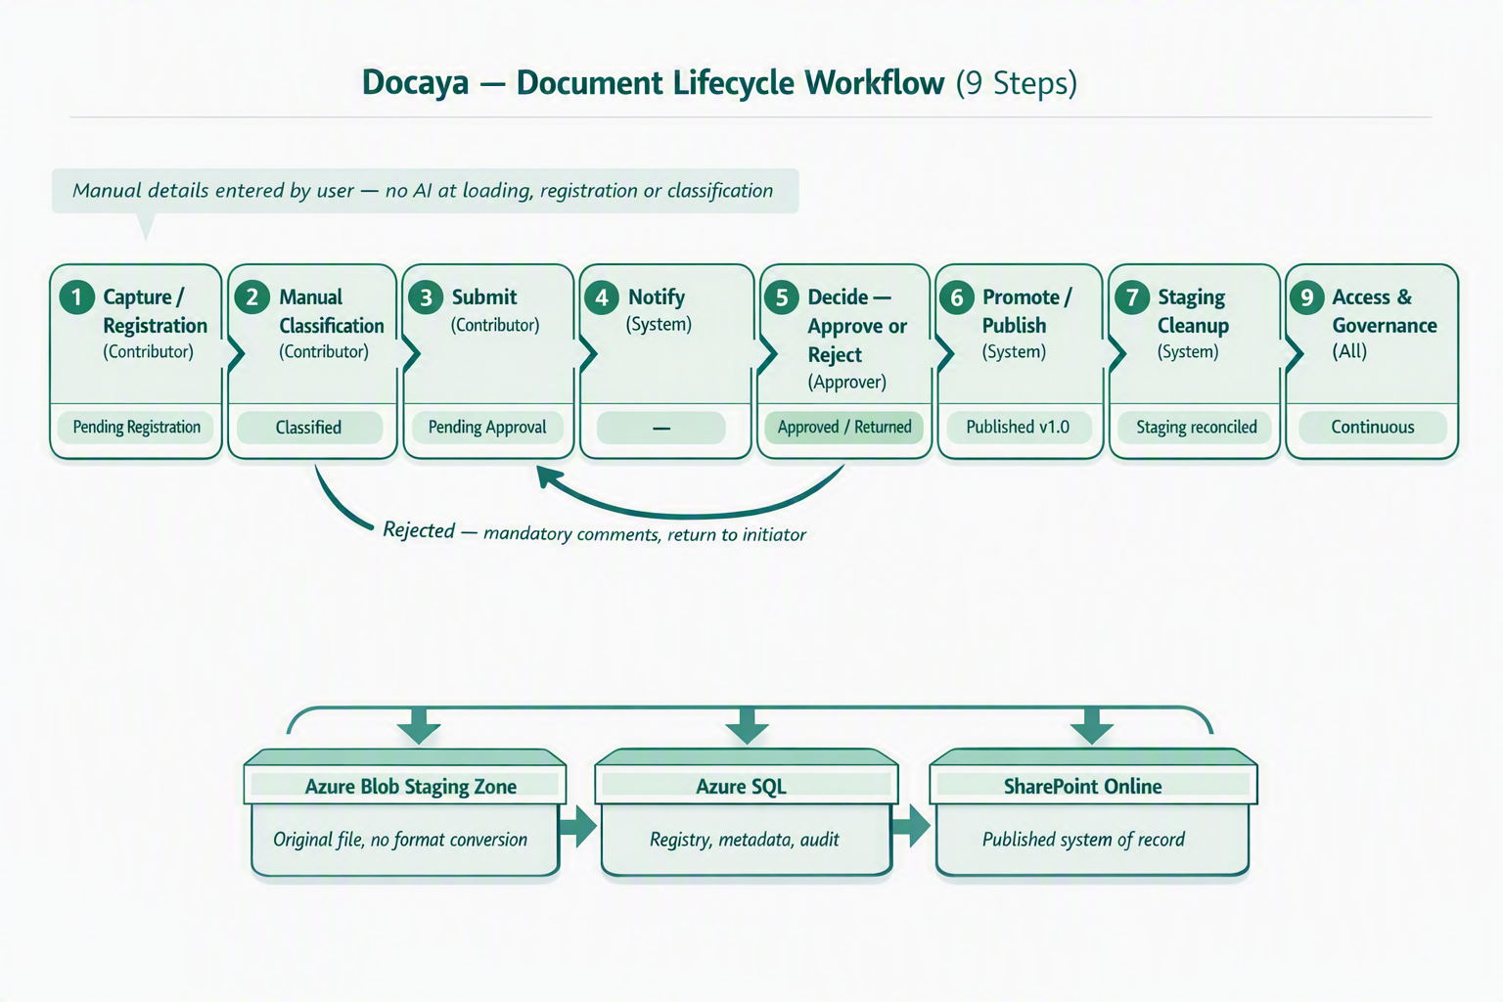

No |  | Stage | Actor | What happens | Status
1 |  | Capture / Registration | Editor / Change Requester | The Editor / Change Requester uploads a single file (PDF, DOCX, XLSX, PNG, JPEG and other supported types) up to a maximum of 100 MB - one file per registration. The original file is stored in the controlled Staging Zone (Azure Blob) - or, where configured, a staging area within a SharePoint site - without converting the file format. A unique tracking number (e.g., DOC-2026-000123) is issued, and a registry row is created in Azure SQL where the document is tracked, monitored and audited. Docaya captures technical attributes such as file name, detected type, size, hash and capture timestamp, and generates the document thumbnail; the Editor manually completes the required registration fields - including the Department Tag and the Document Publishing Scope - before the approval flow starts. | Status → PendingRegistration / Draft
2 |  | Classify | Editor / Change Requester | The Editor manually classifies the document by selecting the document class, sensitivity, owning department and approval flow from Admin-configured values. No AI suggestion, OCR extraction, metadata recommendation or approval recommendation is provided during loading, registration or classification. All classification metadata is written to Azure SQL, and the configured approval flow starts once the required details are complete. | Status → Classified
3 |  | Submit | Editor / Change Requester | The Editor submits. Classification rules determine the target SharePoint library and the review chain. The document moves to PendingApproval and appears in the queue of the first configured review stage (Section 8.4). | Status → PendingApproval
4 |  | Notify | System | At every stage the Notification Center alerts the relevant parties in-app and via email / Microsoft Teams - including the approver on submission and the Editor on each stage decision. | (no status change)
5 |  | Decide | Reviewer at current stage | Each level in the configured three- or four-level review chain performs its own action. The reviewer approves to advance, or returns the item with mandatory threaded comments to the Editor or preceding level for correction and resubmission. SLA status, extensions, stage timings and every action are retained. Only final approval permits promotion to SharePoint. | Status → Approved or → Classified (returned)
6 |  | Promote / Publish | System | Only after final approval, Docaya promotes the approved original PDF, DOCX, PPTX, XLSX, image or other supported file from staging into the correct SharePoint library as the main repository and system of record. No file-format conversion occurs. The SharePoint item ID, URL and version are written back to Azure SQL. | Status → Published (v1.0)
7 |  | Cleanup | System | The staging copy is handled per policy - purged, or moved to a dedicated 'Published/Approved' folder within staging for retention. The Editor is notified of successful publication. | Staging reconciled
8 |  | Upload Processing | System (during upload) | While the supported original file is held in staging, Docaya extracts basic machine-readable text, technical metadata and preview data, and captures the document thumbnail. Business and classification metadata remains user-entered. No content chunking, embeddings, vectors or generative retrieval is performed at this point - that indexing occurs only after final approval and publication, and is used solely by Ask Docaya (Section 15). | Staged file and extraction data ready for review
9 |  | Access & Governance | All | Users access Docaya via UAE PASS single sign-on federated to Entra ID. Access is managed inside Docaya, while the platform reaches SharePoint through a governed service identity that holds read/write on the document estate. This keeps user permissions centralised in Docaya while all content operations occur under one auditable service principal. | Continuous
 | Key promotion rule The original file remains in its native format in staging throughout capture, classification and approval. Only on approval is the same file promoted into the correct live SharePoint Online library and given version 1.0 - at which point it becomes an official Client record.

5.1 Status State Machine
State | Meaning | File location
Draft / PendingRegistration | Uploaded; auto-metadata populated; registration fields being completed | Staging (Blob / SP staging)
Classified | Class, sensitivity, department, approver flow selected | Staging
PendingApproval | Submitted; awaiting the decision of the current review stage | Staging
Returned | Returned with mandatory comments; back with Editor or the immediately preceding review stage | Staging
Approved | Approver signed off; promotion pending | Staging (transient)
Published | Promoted to SharePoint library; version 1.0 | SharePoint Online
Superseded | Replaced by a newer approved version | SharePoint Online
Expiring | Within the expiry notification window | SharePoint Online
Archived / Disposed | Retention reached; archived or defensibly deleted | Archive / removed per policy

6. Module M1 Capture & Document Registration
Upload and staging scope: During upload, Docaya extracts only basic machine-readable data, technical metadata and a text preview from supported files such as PDF, DOCX, PPTX, XLSX and common image formats. The original uploaded file and extracted data are retained in staging. No uploaded document is added to the main SharePoint repository/system of record until the configured approval workflow is completed; after approval, the document is promoted to the controlled repository.

6.1 Functional Design
- Multi-format capture: PDF, DOCX, XLSX, PPTX, PNG, JPEG/JPG, TIFF and other approved MIME types, validated by both extension and file signature.
- Single-file upload only: one file per registration. Drag-and-drop or browse-and-select accepts a single document; bulk or multi-file upload is not supported. Scan-to-PDF and email-in to a per-department address remain on the roadmap and would follow the same one-file-per-registration rule.
- Maximum file size 100 MB: enforced in the browser before transfer and re-validated on the server; oversized files are rejected with a clear message. Upload is resumable and chunked, with progress, cancel and retry.
- Staging-first storage: the original file is written to the Azure Blob Staging Zone (or a SharePoint staging area where configured) in the same format — never directly to a live library and never converted to another format.
- Unique tracking number issued at capture in the format DOC-YYYY-NNNNNN, printed on screen and used across the whole lifecycle.
- Azure SQL registry row created immediately; the document is tracked, monitored and audited from this moment, with an initial status.
- Content integrity: a SHA-256 hash is computed for de-duplication and tamper detection; malware and DLP checks run before the item can proceed.
- Document thumbnail capture: a preview image of the document (cover or first page) is generated automatically at registration and referenced against the registry row, for later display in Ask Docaya results and version history (Section 15.4).
- Document tagging at registration: the Editor applies the Department Tag (one owning department plus any additional related departments) and the Document Publishing Scope - Departmental, Cross-Departmental, Organisation-wide or Public - alongside the standard and keyword tags. These tags drive navigation, permission scope, Ask Docaya filtering and the reach of the publication notification (Module M7).

6.2 Auto-Populated vs. User-Entered Fields
On the registration screen Docaya auto-detects and pre-fills technical attributes; the Editor supplies the business context.
Auto-populated by Docaya (technical attributes) |  | Entered manually by the Editor
Document name (from file, editable) |  | Business title / subject
Detected document type / MIME |  | Document class (see M2)
File size and page count |  | Owning department
Content hash (SHA-256) |  | Sensitivity / handling marking
Capture timestamp & channel |  | Description / keywords / reference
Tracking number (DOC-YYYY-NNNNNN) |  | Retention / expiry hints (optional)
Uploader role / authenticated user reference |  | Approver flow selection
Document thumbnail (cover / first page preview) |  | Department Tag and Document Publishing Scope
 | Registration = accountability The Azure SQL registry is the single source of truth for chain of custody. From the instant a tracking number is issued, every view, edit, decision and movement is recorded against it.

7. Module M2 Classification & Metadata
Classification is Editor-driven and rules-aware. The Editor selects all business and classification values manually from Admin-configured controls. Only technical attributes, basic machine-readable text and preview data are extracted during upload while the file remains in staging; no AI classification or recommendation is used.

7.1 Classification Dimensions
Dimension | Purpose | Example values
Document class | Determines target library & schema | Correspondence, Memo, Circular, Contract, HR Record, Report, Policy
Sensitivity / handling | Drives access & approval routing | Public, Internal, Confidential, Secret
Owning department | Ownership & routing | e.g., Finance, HR, Legal, Operations
Priority | Queue ordering & SLA | Routine, Priority, Urgent
Approval flow | Selects approver chain | Single, Sequential, Parallel
Access scope (ABAC) | Attribute-based restriction | Department-only, Named group, Clearance level
Standard | Groups the document for navigation, filtering and reporting by the standard it supports | ISO 9001, ISO 27001, Health & Safety, IMS, AI Governance
Department Tag | Identifies the owning department and any additional related departments; drives navigation, filtering and the department-wide publication alert | Finance, HR, Legal, Operations, Health & Safety, IT
Document Publishing Scope | Determines how widely the approved document is published, who sees it in Ask Docaya, and how far the publication notification reaches | Departmental, Cross-Departmental, Organisation-wide, Public

7.2 Manual Classification Controls
- User-entered business metadata: Docaya does not generate classification, business metadata or approval recommendations. During upload it extracts only basic machine-readable text, technical metadata and preview data for the staged file.
- Manual details required: the Editor manually enters or selects the business title, document class, sensitivity, owning department, Department Tag, Document Publishing Scope, description, keywords/reference and approval flow.
- Schema validation: metadata is validated against the configurable document-type schema before submission is allowed.
- Approval-flow enforcement: once the manual details are complete, Docaya routes the document through the configured approval flow.
- Azure SQL persistence: classification, workflow status, audit trail and SharePoint promotion references are fully auditable and reportable.

8. Module M3 Workflow & Approval

8.1 Submission & Routing
On submission, classification rules resolve the target SharePoint library and the approver(s). The document enters Pending Approval and is placed on the approver's queue with full context and preview.

8.2 Approval Patterns
Pattern | Behaviour | Typical use
Single | One approver decides | Routine internal documents
Sequential | Approvers act in order; each must approve to proceed | Confidential / multi-level sign-off
Parallel | Multiple approvers in parallel; quorum or unanimous | Cross-department documents
Conditional | Route by rule (e.g., sensitivity = Secret → senior + compliance) | Sensitive or high-value records

8.3 Decision Handling
- Approve: the document is marked Approved and immediately promoted (Module M4) to the final class/library selected by the Editor.
- Reject / Request changes: mandatory comments (more information) are required; the document returns to the initiator as Returned/Classified for correction and re-submission.
- SLA & escalation: each approval task carries an SLA timer; on breach it escalates to the configured delegate or manager and raises a notification.
- Act anywhere: approvers can decide from the in-app queue, email action buttons, or Microsoft Teams.
- Delegation: out-of-office auto-reassignment keeps the queue moving.
Mandatory rejection reason A rejection cannot be submitted without comments. This guarantees the initiator always receives actionable feedback and preserves a complete decision record in the audit trail.

8.4 Configurable multi-level review chain
The patterns in 8.2 remain routing primitives. The approval workflow is a configurable, named sequence of three or four levels set by the Admin Center per document type or department, with threaded comments and actions, return and resubmission, SLA and extension handling, stage timings, and complete audit/version history:
Stage | Default role | Purpose
1 | Editor / Change Requester | Submits a new document or a change request against an existing one
2 | Document Owner / Approver | First substantive review; approves or returns with comments
3 | Assurance | Quality/compliance check; approves, returns, or grants a timeline extension with a recorded reason
4 | Authoriser (typically CEO) | Final sign-off; approves for publication or returns for further amendment
- Admin-configurable: number of stages (3 or 4), role at each stage, and whether a stage is mandatory or optional are set per document type/department in M13 Admin Center - no engineering change required to adjust the route.
- Any stage can return the item to the Editor or to the immediately preceding stage with mandatory comments; the item re-enters the chain at the point of correction, not necessarily at Stage 1.
- Each stage inherits the SLA and escalation model described in 8.6.

8.5 Threaded comments & actions
Every submission, return, amendment and resubmission is captured in a per-document thread. Each entry records actor, role or stage, action, comment and timestamp. The thread is visible to subsequent reviewers and is retained with stage timings, SLA and extension events, full audit history and SharePoint version history for Module M16.

8.6 Change-request SLA & timeline engine
Each change request is classified as Urgent or Normal at submission, which sets its target completion window in working days (public holidays and weekends excluded):
Request type | Target | Extension
Urgent | 12 working days end-to-end | Assurance can approve an extension; reason is mandatory and recorded on the thread
Normal | 30 working days end-to-end | Assurance can approve an extension; reason is mandatory and recorded on the thread
- A running remaining-days counter is shown on every request; requests within a configurable warning window are flagged ‘at risk’, and requests past target are flagged ‘overdue’ - both are terms the Notification Center (M7) can alert on.
- Stage-level duration is captured automatically: the time an item spends with each of Document Owner, Assurance, and Authoriser is stored against the thread entry for that stage, so a delay can be attributed to a specific stage rather than only shown as ‘overdue’ in aggregate. This feeds the bottleneck reporting in Module M15.
- Extensions are logged as a distinct event type (new target date, approver, reason) so the original target is never overwritten - both dates remain visible for reporting.
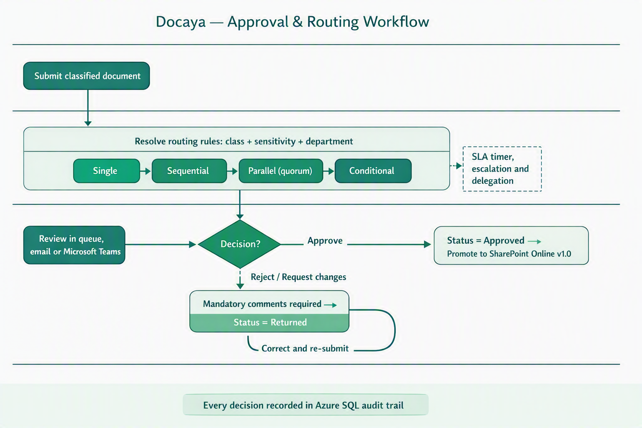

Figure 2 - Approval and routing workflow: rule-based routing, the four approval patterns, SLA escalation and the mandatory-comment return path.

9. Module M4 Promotion & Publishing
- Immediate promotion: on approval, Durable Functions orchestrate the move from staging into the correct live SharePoint library path for the document's final class.
- Microsoft Graph upload transfers the original file stream without changing the file format; SharePoint's native versioning assigns version 1.0.
- Write-back to Azure SQL: SharePoint Item ID, Drive/Library ID, web URL and version label are captured on the registry row, linking record and content.
- Idempotent promotion: an idempotency key ensures a retry can never create a duplicate SharePoint item.
- Native versioning thereafter: subsequent approved edits create new SharePoint versions (2.0, 3.0 …); Docaya records the version label.
- Failure safety: if promotion fails, the item remains recoverable and visible in staging; the original file is never lost.

10. Module M5 Staging Lifecycle & Cleanup
Situation | Cleanup behaviour
Document published | Staging copy of the original file purged, OR moved to a dedicated 'Published / Approved' folder in staging per retention policy
Document rejected / returned | Original file retained in staging under the initiator until corrected and re-submitted
Abandoned draft | Auto-expiry after a configurable period, with owner notification before removal
Failed promotion | Original file retained and flagged for operational replay via idempotent retry
- Lifecycle rules on the staging container keep stoe costs controlled while preserving auditability.
- Editor / Change Requester notified of successful publication with a direct link to the SharePoint record.

11. Module M6 Upload Text Extraction & Search Data
A scheduled batch process builds and maintains a document metadata and text-preview processing index using Azure metadata and full-text search. It draws on both the document metadata registered in Azure SQL (all information the initiator and approver entered on screen) and the published content in SharePoint, enabling the metadata and full-text search and inside the application.

11.1 Pipeline Stages
Stage | Action | Output
1 · Stage | Store the original supported file in controlled staging | Original file retained unchanged
2 · Extract | During upload, extract basic machine-readable/source text, technical metadata and preview data | Staged technical extraction data
3 · Register | User enters business title, class, sensitivity, department, keywords and approval route | Validated business metadata
4 · Review | Run the configurable three- or four-level review with threaded actions, return/resubmission, SLA, extensions and stage timings | Complete review and audit history
5 · Promote | After final approval, promote the approved file to SharePoint as system of record | Approved SharePoint version
6 · Search | Search approved records using permission-trimmed metadata and full-text/source-text matching | Authorised search results

11.2 Design Principles
- Grounded & cited: 'document search' searches only indexed Client documents the user is permitted to see, with links back to the exact document/version.
- Permission-trimmed retrieval: every query carries the user's effective ACL keys; the index never returns content the user cannot access.
- Metadata + content fusion: because all registration data lives in Azure SQL, search can combine structured filters (department, class, sensitivity, date) with approved source-text search.
- Batch cadence: configurable schedule (e.g., near-real-time micro-batches or scheduled runs) with full re-index capability.
- Embeddings after approval only: once a document is published, the batch also produces the document embedding and refreshes the snapshot reference, forming the Document Index Record consumed by Ask Docaya (Section 15.3).
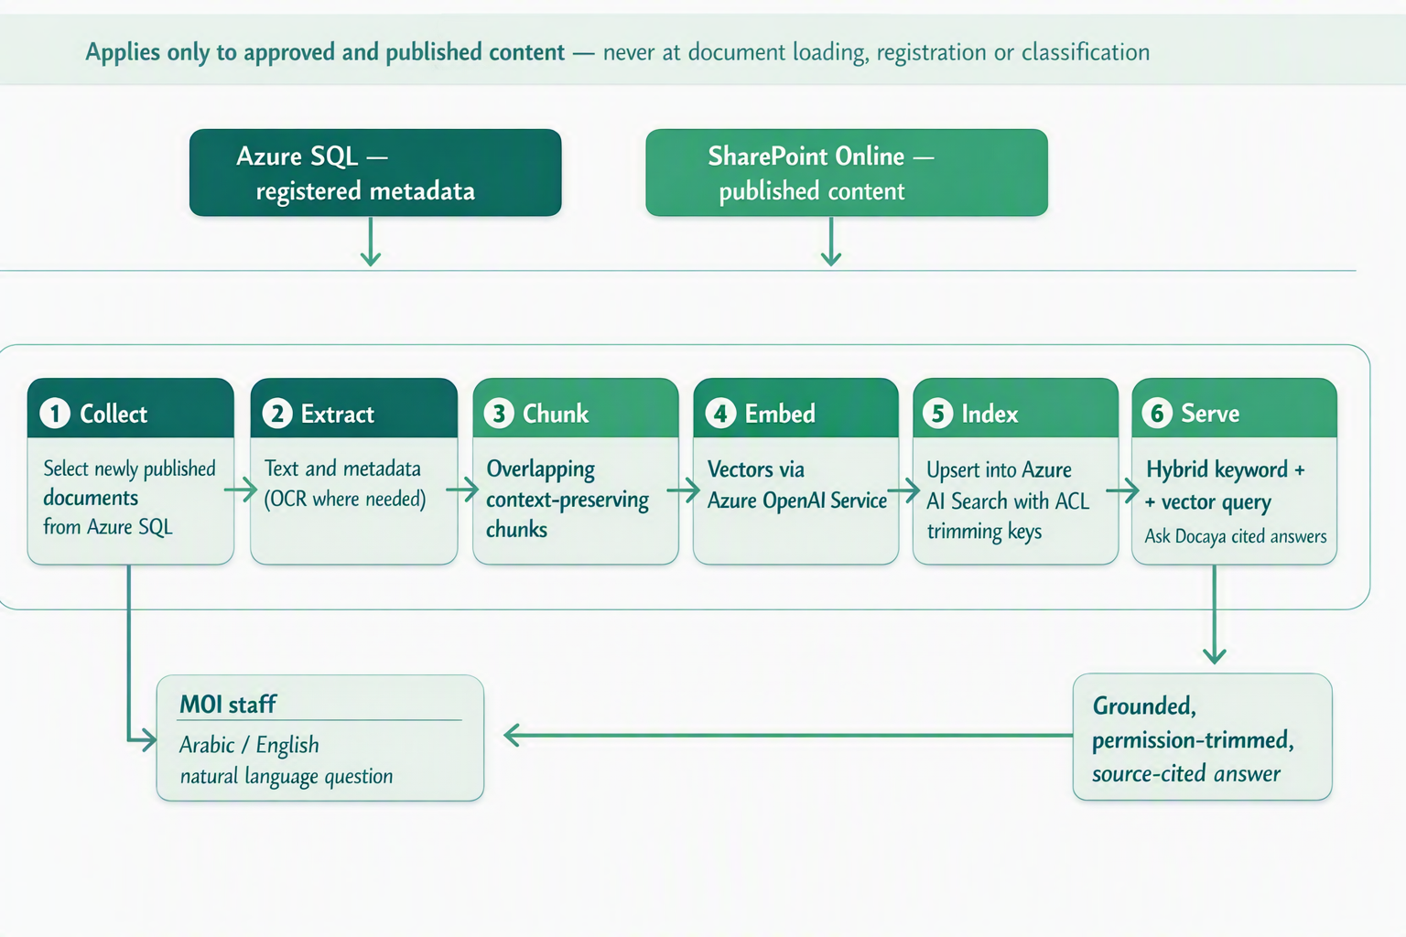
Figure 3 - Batch document indexing and search pipeline, applied only to approved and published content.
Why document indexing matters: it turns the approved document estate into an answerable knowledge base. Staff can search in Arabic or English and receive source-backed results drawn only from published documents they are authorised to view. It is never applied at document loading, registration or classification.

12. Module M7 Notification Center
The Notification Center is a first-class surface that keeps every actor informed at every lifecycle stage, with zero noise.
Category | Examples | Default channels
Workflow | Approval requested, approved, rejected, SLA breach, escalation | In-app, Email, Teams
Registration | Document registered, submitted, returned for changes | In-app, Email
Publication | Successfully promoted to SharePoint, new version | In-app, Email
Expiry / Lifecycle | T-30 / T-7 / T-1 day reminders, retention due | In-app, Email
Security | Permission change, unusual access, external share (locked, mandatory) | In-app, Email, Push
System | Storage, maintenance, upload-processing status | In-app, Email
Change request | SLA at-risk warning, overdue flag, extension granted | In-app, Email, Teams
- Real-time delivery via Azure SignalR; durable history retained in Azure SQL.
- Per-user preferences per notification type and channel; security notifications are mandatory and non-disable-able.
- Smart batching, DND windows and de-duplication prevent alert fatigue; delivery via email (ACS) and Teams/Outlook (Graph).

13. Module M8 Correspondence Management
Client organisations run on correspondence. Docaya adds a dedicated correspondence capability on top of the core pipeline, designed to support the Client’s day-to-day operational requirement.
- Incoming & outgoing correspondence captured with a formal reference number, sender/recipient, subject and due date.
- Memos & circulars with structured templates, distribution lists and read-acknowledgement tracking.
- Linking & threading relate a reply to its original correspondence to preserve the full thread.
- Routing & action tracking assign, forward, and track actions with due dates and escalation.
- Bilingual Arabic/English correspondence with RTL layout.

14. Module M9 Records, Retention & Legal Hold
Capability | Design
Retention schedules | Time-based or event-based policies per document class, aligned to the Client's records policy
Disposition | Auto-archive, review-then-delete, or defensible permanent deletion with approval
Legal hold | Overrides retention; freezes documents, blocks deletion, fully audited
Records declaration | Freeze metadata + content for compliance / evidential integrity
Archive tiering | Move cold records to archive stoe while preserving the registry link
Data residency | All data pinned to UAE Azure regions to satisfy PDPL and IA requirements

15. Module M10 Ask Docaya - Search, Discovery & AI Answering
Ask Docaya is the single place a user goes to find anything in the document estate. Instead of asking staff to choose between "search", "browse" and "AI", Docaya presents one box and one result surface. The user types either a keyword, a tracking number or a full question in Arabic or English; Ask Docaya decides how to answer it, answers only from documents that have completed the approval lifecycle, and shows only what that specific user is permitted to see.
Two retrieval sources sit behind that one box: the document metadata held in Azure SQL (everything the initiator and the reviewers entered on screen, plus the technical attributes captured at upload), and the document embedding generated from the approved file only once the document has been fully approved and published. Every result is accompanied by the document snapshot captured when the document was first registered, or when its latest version was approved. The core capabilities are:
- Search combines permission-trimmed metadata, full-text/source-text matching and faceted filters.
- Faceted filters: class, department, sensitivity, owner, date, status, tracking number.
- Permission-trimmed: results always honour the user's effective rights (no unauthorised results).
- Permission-trimmed metadata and full-text/source-text search across approved documents (Module M6).
- Saved searches & smart views for recurring departmental queries.

15.1 Ask Docaya nomenclature
These terms are used consistently across this document, the user interface and the Admin Center, so that business users, reviewers and the delivery team describe the same thing the same way.
Term | Agreed meaning
Ask Docaya | The single search-and-answer module (M10). It covers keyword search, faceted browsing and AI answering under one name and one entry point.
Quick Search | Structured, keyword and filter-driven search answered from the Azure SQL registry metadata and the approved source text.
Ask (AI Search) | Natural-language question answering over the document embeddings of approved, published content, returned as a short written answer with citations.
Document Index Record (DIR) | One indexed entry per approved document version, holding its metadata, properties, text, embedding and snapshot reference.
Document Embedding | The vector representation of the approved document's text, created only after final approval and publication - never at upload, registration or classification.
Document Snapshot | The system-generated visual preview (cover or first page) captured automatically at new document registration and again at every approved version update, and shown with the search result.
Answer Card | The response block shown above the result list: plain-language answer, the documents it was drawn from, and the snapshot of the leading source.
Citation | The link back to the exact document, tracking number and version that a statement came from.
Permission trim | The RBAC + ABAC filter (Module M12) applied to every query, so unauthorised documents, snapshots and answer text are never returned.

15.2 One box, three ways to find a document
The user is never asked to pick a mode. Ask Docaya reads the input and routes it automatically; the modes below describe what happens behind the single box.
Mode | What the user does | Where the answer comes from | Typical example
Quick Search | Types a keyword, document name or tracking number and optionally applies facets | Azure SQL registry metadata plus the approved source text (Module M6) | "DOC-2026-000123" or "information security policy"
Ask (AI Search) | Asks a full question in Arabic or English | Document embeddings of approved content, combined with registry metadata for filtering | "What is the escalation route if an urgent change request passes its target date?"
Browse | Navigates the Department or Standard tabs and narrows with filters | Azure SQL registry metadata and the Admin-configured taxonomy | "Show everything under Health & Safety, status Published"

15.3 What Ask Docaya searches - the Document Index Record
A Document Index Record is created for each approved document version. It is the only thing Ask Docaya ever reads from, which is what guarantees that unapproved material can never be surfaced or summarised.
Element | Source | Typical content | Created when
Business metadata | Azure SQL registry (M1, M2) | Tracking number, business title, class, sensitivity, owning department, standard, owner, keywords, status, version, approval and expiry dates | At registration; kept in step with every approved change
Technical properties | Capture service (M1) | File type, size, page count, detected language, content hash | At upload
Approved document text | Published file in SharePoint Online (M4, M6) | Source text divided into passages, each retaining its document, version and page reference for citation | After final approval and publication only
Document embedding | Indexing service (M6) | Vector representation of each approved passage, enabling meaning-based retrieval across Arabic and English | After final approval and publication only
Document snapshot reference | Snapshot capture at registration (M1) and version update (M14) | Pointer to the stored preview image for that specific version | At registration and at each approved version
Security keys | Access Control Service (M12) | Department, sensitivity and clearance keys used to trim every query result | Evaluated at query time, never cached per user

15.4 Document Snapshot
A snapshot is a small preview image of the document - normally its cover or first page - generated automatically by Docaya. It exists so that a user scanning a result list can recognise the right document visually before opening anything, and so that each historic version can be identified at a glance.
- Capture point 1 - New Document Registration: when the Editor registers a new document (Module M1), Docaya captures the snapshot from the staged original file alongside the technical attributes, and stores the reference against the registry row.
- Capture point 2 - Document Version Update: when a change request is finally approved and a new version is promoted (Module M14, Module M4), a fresh snapshot is captured for that version.
- One snapshot per version: earlier snapshots are retained against their own version rather than overwritten, so the version history in Module M16 can show what each approved state looked like.
- Where it appears: in the Ask Docaya result list, in the Answer Card for the leading source, in the department and standard listings, and in the document-level history view.
- Same permission rules as the document: a snapshot is treated as document content, so it is permission-trimmed identically - if the user may not see the document, they do not see its snapshot.
- Redaction-aware: for classes where even a cover page is sensitive, the Admin Center can suppress snapshot display and fall back to a neutral document-type icon.

15.5 Ask Docaya process flow - end to end
The flow below is the common process understanding for Ask Docaya. Steps are referenced as AD-1 to AD-9 throughout design, testing and training material. Everything upstream of AD-1 - capture, registration, classification, review and promotion - is unchanged; Ask Docaya begins only once a document has been published.
Step | Stage | What happens | Owning module
AD-1 | Ask | The user enters a keyword, tracking number or full question in Arabic or English into the single Ask Docaya box, optionally with facets already applied. | M10
AD-2 | Interpret | Ask Docaya detects the language, recognises whether the input is a lookup or a question, and lifts any implied filters such as department, standard, document class, status or date range. | M10
AD-3 | Authorise | The user's effective permission is resolved from RBAC + ABAC and converted into the security keys carried by the query. This happens before any retrieval, not after. | M12
AD-4 | Retrieve - metadata | A structured query runs against the Azure SQL registry metadata and approved source text - tracking number, title, class, sensitivity, department, standard, owner, status, version and dates. | M10 · M1 · M2
AD-5 | Retrieve - semantic | In parallel, the question is matched against the document embeddings created after approval, so a document is found on meaning rather than exact wording - including across Arabic and English. | M6
AD-6 | Merge & rank | The two result sets are merged and ranked together. Only Published or otherwise approved versions are eligible; superseded, expiring, draft, returned and rejected items are filtered out unless the user explicitly asks for history. | M10
AD-7 | Compose | For a question, a short natural-language answer is written in the user's language using only the retrieved approved passages, with a citation against each statement. If nothing adequate is found, Ask Docaya says so rather than inferring an answer. | M10
AD-8 | Present | The Answer Card is shown above the ranked result list. Each row carries the document snapshot, key metadata and one-click view, download or open-in-SharePoint actions. | M10 · M4
AD-9 | Log | The query, the filters applied, the documents returned and anything opened or downloaded are written to the audit trail and feed search and access analytics. | M16 · M15

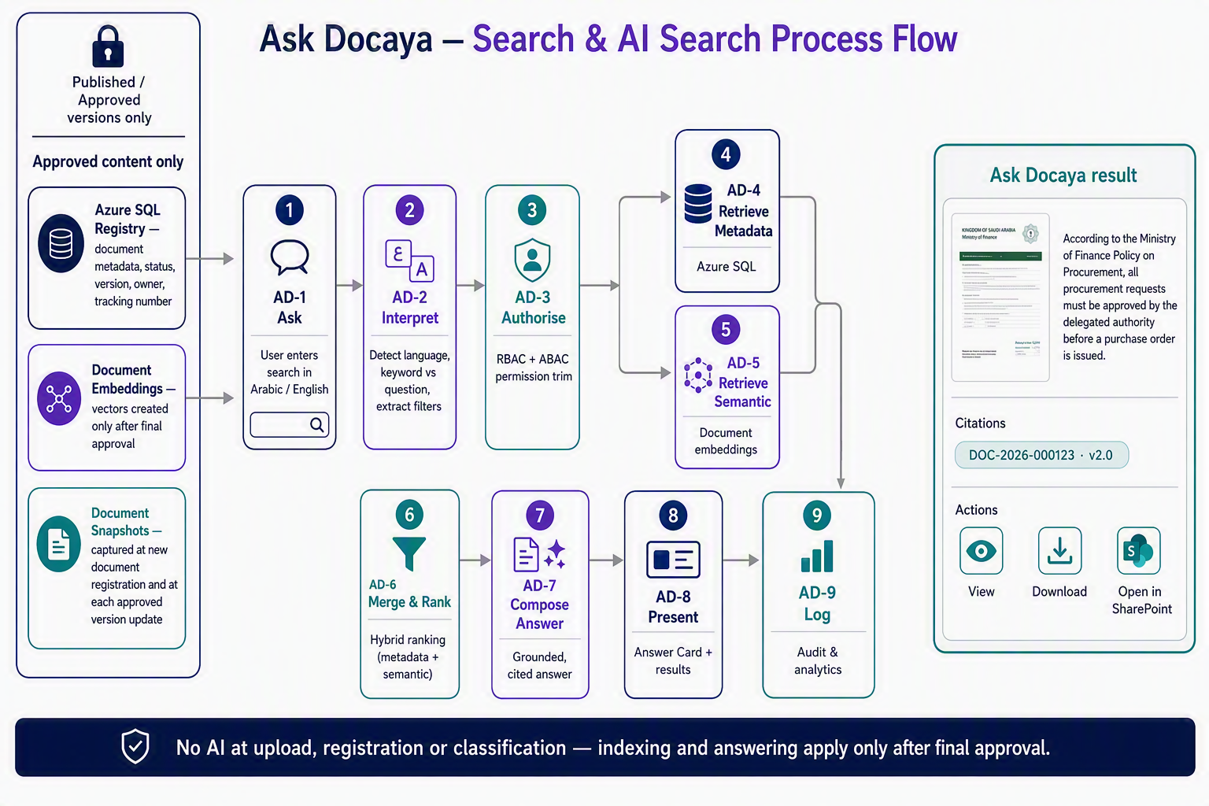
Figure 4 - Ask Docaya process flow: one search box, permission-trimmed retrieval from Azure SQL metadata and post-approval document embeddings, hybrid ranking, a cited natural-language answer, and results presented with the document snapshot captured at registration or version update.

15.6 What the user sees
- Answer Card: a short plain-language answer in the language of the question, with the snapshot of the leading source document beside it and a citation for every statement made.
- Result row: document snapshot, business title, tracking number, class, owning department, standard, sensitivity marking, status and current version, with the last approval date.
- One-click actions: preview in the browser, download the original file, or open the SharePoint location - each subject to the user's effective permission (Module M12).
- Version awareness: the current approved version is always returned first; earlier versions are reachable from the document history rather than mixed into the main results.
- Saved searches and smart views: a question or filter set can be saved and re-run, and shared with colleagues who hold the same rights.

15.7 Governance rules for Ask Docaya
- Approved content only: indexing, embedding and answering happen after final approval and publication. Nothing in staging - draft, classified, pending, returned or rejected - is ever searchable or answerable.
- No AI at capture, registration or classification: Ask Docaya does not suggest metadata, classification or approvers. This preserves the manual, Editor-driven model set out in Modules M1 and M2.
- Grounded and cited: no citation, no statement. Where the approved estate does not contain the answer, Ask Docaya reports that plainly instead of generalising.
- Permission-trimmed at query time: answer text, citations, snapshots and result rows are all filtered by the user's effective rights on every request.
- Bilingual by design: questions and answers are supported in Arabic and English with full RTL rendering, including questions asked in one language against documents written in the other.
- Data residency: indexing, embedding and answering run entirely within the UAE Azure regions used by the rest of the platform, consistent with Module M9.
- Fully audited: every query and every document opened from a result is recorded in the tamper-evident audit trail (Module M16) and reported through Analytics (Module M15).

15.8 Department / standard navigation
The document library view is organised as tabs or categories by Department and/or Standard (e.g. Health & Safety, AI, IMS, Information Security, Finance, HR). The grouping taxonomy is Admin-configurable in M13 so new departments or standards can be added without a release.

15.9 One-click access
From any listing row the user can view the document (in-browser preview), download the original file, or open its SharePoint folder - each in a single click, subject to the user’s effective permission (Module M12).

15.10 Extended filters
The faceted filters above are extended with: document name (free text), standard, owner, and status, so results can be narrowed the same way whether the user is browsing by department tab or running a search.

16. Module M11 Identity, SSO & SharePoint Integration

16.1 Single Sign-On with UAE PASS
- UAE PASS as primary identity: users sign in with the UAE national digital identity, federated to Microsoft Entra ID for the Docaya application.
- Standards-based: OIDC + PKCE for the single-page app; MFA and Conditional Access enforced by Entra.
- Step-up authentication for sensitive actions such as approving Secret documents or changing permissions.

16.2 Governed SharePoint Service Identity
Docaya integrates with SharePoint through a single governed service identity (system/service principal) that holds read and write access across the Docaya document estate. Once a user signs in to Docaya, their access is managed within Docaya (RBAC + ABAC), while all content operations against SharePoint are performed under this one auditable service identity.
Aspect |  | Design decision | Benefit
User access |  | Centrally managed inside Docaya (roles + attributes) | Single, consistent control point
SharePoint access |  | Performed by the Docaya service identity (read/write on the estate) | Uniform, auditable content operations
Credential |  | Managed identity / workload identity - no stored user passwords | Least-privilege, no secret sprawl
Authorization |  | Docaya enforces who can see/do what before any SharePoint call | Defence in depth
Audit |  | Every action attributed to the real user in Azure SQL, executed by the service identity | Full accountability
 | Integration model Users never touch SharePoint permissions directly. Docaya is the governance layer: it decides access, then acts on SharePoint Online through one controlled Entra ID service identity - keeping permission management simple, centralised and fully audited.

17. Module M12 Access Control (RBAC + ABAC)
- RBAC: roles/app-roles (Section 3) grant baseline capabilities.
- ABAC overlays: attributes such as department, sensitivity and clearance refine access (e.g., 'Confidential HR records visible to HR only').
- Deny-by-default: no access unless explicitly granted; every decision is logged.
- Effective-permission evaluation combines role + attribute + document scope before any read, download or action.

18. Module M13 Admin Center
A no-code control plane so Client administrators configure the system without engineering tickets.
Area | Configurable items
Document types & schemas | Create/edit classes, metadata fields, validation, controlled vocabularies
Routing rules | Map class + sensitivity + department to target library and approvers
Workflows | Design single/sequential/parallel/conditional flows; SLA & escalation
Notifications | Templates (Arabic/English), default channels, quiet hours
Retention & legal hold | Schedules, dispositions, holds
Security | MFA enforcement, session policy, step-up rules, IP allowlists
Branding & localisation | Client branding, bilingual labels, RTL defaults
Integrations | Service identity, connectors, webhooks, API keys
Approval-level designer | Number of review stages (3–4), role per stage, mandatory/optional flag, SLA targets (urgent/normal working days), at-risk warning window, who may grant extensions - scoped globally, by document type, or by department
Navigation taxonomy | Department and Standard categories shown as tabs in the document library (Section 15.1)

19. Module M14 - Existing Document Modification
Existing Document Modification is a separate module for controlled changes to approved documents. A requester opens a change request against the current SharePoint version, records rationale, priority and target date, and prepares amendments without overwriting the approved record.
The proposed revision follows the configurable three- or four-level review workflow with threaded comments and actions, return and resubmission, working-day SLA controls, recorded extensions, stage timings and a complete audit trail. Only final approval creates and promotes the next SharePoint version; the prior approved version remains available in history. On that approval Docaya captures a new document snapshot for the new version and refreshes its index record - metadata, approved text and embedding - so Ask Docaya (Section 15) immediately returns the current approved content, while the earlier snapshot stays attached to its own version.

20. Module M15 - Analytics
Docaya delivers in-application analytics through a dedicated Analytics module built over Power BI. Reports and dashboards are embedded and rendered directly inside Docaya, so users see governed, permission-trimmed reporting without leaving the application. Every report reads from the same Azure SQL registry, classification, workflow and audit stores populated by Modules M1-M16 - there is no separate analytics pipeline or data duplication to maintain.

20.1 Reporting & Power BI Architecture
- Embedded Power BI: reports and dashboards are embedded in the Docaya UI via Power BI Embedded, so no separate Power BI licence or sign-in is required for end users.
- Reporting data model: a dedicated semantic model / reporting layer sits over Azure SQL, covering the document registry, classification metadata, workflow and stage-timing data, and the audit store.
- Refresh cadence: operational dashboards (pending approvals, SLA status) reflect near-real-time data; trend and historical dashboards refresh on a scheduled cycle.
- Row-level security: Power BI row-level security mirrors Docaya's RBAC + ABAC model, so each user's dashboards and exports are automatically trimmed to the documents, departments and classes they are permitted to see.

20.2 Metadata & Classification Reports
Reports driven by document metadata captured at registration and classification (Modules M1-M2):
- Volume analysis: document counts by class, department, standard and status, with period-over-period trend.
- Sensitivity distribution: breakdown of documents by sensitivity marking, for governance and risk reporting.
- Most-accessed & most-downloaded: top records by view/download activity, permission-trimmed to the viewer.
- Stale or inactive content: documents not reviewed, updated or accessed within a configurable period.
- Ownership view: documents grouped by owner, business unit or department for accountability reporting.

20.3 Workflow & Change-Request Reports
Operational dashboards: documents registered, pending approvals, cycle time, SLA compliance and promotion backlog, all drawn from the workflow engine (Module M3).

Docaya's native reporting module already connects to Azure SQL for the dashboards above (Section 22.1). Four additional dashboards read from the stage-level timing and thread data captured by Module M3 and the audit store in Module M16 - no separate analytics pipeline is required:
Dashboard | Content
Change requests | Total open / closed / overdue, urgent vs normal split, average completion time, monthly trend
Department / user analysis | Requests raised by department and by user, filterable by month/year
Performance | % completed within target, overdue count, extensions granted, average time spent at each approval stage
Document control | Documents due for review, overdue reviews, pending approvals, recently revised documents, documents by department/standard

20.4 Audit & Compliance Reports
- Compliance dashboards: documents under retention, upcoming dispositions, active legal holds and access anomalies.
- Full audit exports: the tamper-evident audit trail (Module M16) - who did what, to which document, and when - exportable per document, per user or per date range for regulator or internal audit requests.
- e-Signature status: completion certificates and outstanding signature requests for approvals requiring signed sign-off.
- Access anomaly flags: unusual download or access patterns surfaced for review.

20.5 Standard Reports Library & Export
- Standard report templates: a pre-built library covering each area above (metadata, workflow, audit, compliance), runnable on demand or on a schedule.
- Scheduled reports & exports: PDF/XLSX/CSV, delivered in-app or by scheduled email subscription.
- Access-report builder: an ad hoc, filterable builder for audits - by date range, department, class, document type or user.

21. Module M16 - Audit & Compliance
- Tamper-evident audit: every action (register, classify, submit, decide, promote, view, download, permission change) recorded in a hash-chained Azure SQL audit log.
- Full attribution: actor, action, object, tracking number, timestamp, request ID, source IP and outcome.
- e-Signature: native or integrated e-signature for approvals requiring signed sign-off, with certificate of completion.
- Standards alignment: designed for UAE IA standards, PDPL, ISO 27001 and records-management best practice, as required by the Client.

21.1 Full audit trail & version history
The audit log above now surfaces as a document-level history view combining: who requested the change, every comment raised at every stage, amendments made, decision dates, approvals/rejections, links to previous file versions (via M4’s SharePoint versioning), and the current approved version. This is the thread described in Module M3, Section 8.5, rendered as a single chronological record per document.
- Every thread entry remains individually attributed and timestamped, consistent with the existing audit model.
- Version history links the audit thread to the specific SharePoint version (v1.0, v2.0, …) that resulted from each approval, so any past state of a document can be reconstructed.

22. Reference Architecture
The architecture has been revalidated against the updated functional flow: manual registration and classification with no AI at document loading, no file-format conversion between staging and publication, and approval-driven promotion into SharePoint Online. Every component below is a native Azure or Microsoft 365 service - no third-party platform is required. The staging-first promotion path is the backbone of the governed lifecycle.

22.1 Solution Architecture - Azure & Microsoft Building Blocks
Layer | Microsoft / Azure service | Role in the updated flow
Experience | Azure Static Web Apps / Azure App Service, Microsoft Teams & Outlook surfaces | Bilingual (AR/EN, RTL) web client for upload, manual registration form, approver queue and search
Identity | UAE PASS federated to Microsoft Entra ID; Entra managed identity | SSO, MFA and Conditional Access for users; secretless service identity for SharePoint operations
API & gateway | Azure API Management, Azure Front Door / Application Gateway (WAF) | Secure entry point, throttling, token validation and routing to Docaya services
Application | Azure App Service / Azure Container Apps | Registration, classification, workflow, admin, notification and search services (M1–M16)
Orchestration | Azure Durable Functions, Azure Service Bus | Approval routing, SLA timers, escalation and idempotent promotion of the original file
Staging store | Azure Blob Stoe (private endpoint) or a configured SharePoint staging area | Holds the file in its original format until approval; no conversion, lifecycle rules for cleanup
Registry & audit | Azure SQL Database | Tracking number, manually entered metadata, status, approval decisions and hash-chained audit
System of record | SharePoint Online via Microsoft Graph | Final library for the approved original file, native versioning from v1.0
Search (post-publish) | Azure metadata and full-text search + Service (batch document indexing) | Indexes approved content only - never invoked during loading, registration or classification
Notifications | Azure SignalR Service, Azure Communication Services, Microsoft Graph (Teams/Outlook) | Real-time in-app alerts plus email and Teams delivery at every lifecycle stage
Security & ops | Azure Key Vault, Microsoft Defender for Cloud, Microsoft Purview, Azure Monitor & Log Analytics | Key management, threat protection, classification/DLP, observability and IA/PDPL evidence
Analytics | Docaya native reporting module backed by Azure SQL | Operational, compliance and lifecycle dashboards (M15) + change-request governance dashboards (Section 20.3)

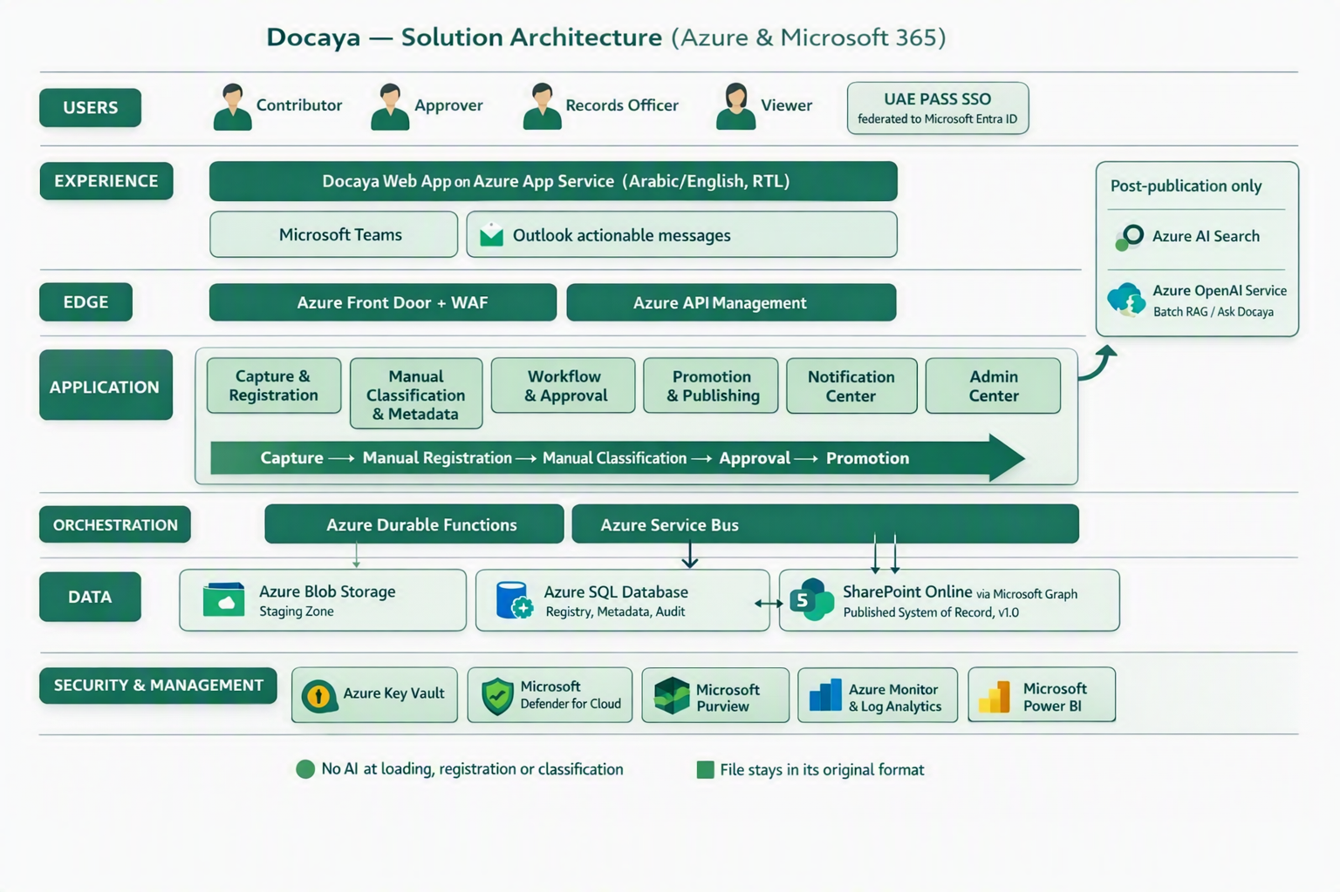
Figure 5 - Docaya solution architecture on Azure and Microsoft 365: staging-first capture, manual registration and classification, approval-driven promotion in the original file format, and AI/document indexing applied only after publication.

22.2 Application Architecture - Component View
Component | Responsibility | Depends on
Capture & Registration Service (M1) | Chunked upload, format and signature validation, SHA-256 hash, tracking number, registry row | Azure Blob Stoe, Azure SQL, Defender for Stoe
Classification Service (M2) | Serves Admin-configured dropdowns, validates the manually entered metadata against the type schema - no AI inference | Azure SQL, Admin Center configuration
Workflow Engine (M3) | Resolves the configured approval flow, manages SLA timers, escalation and delegation; now also resolves the multi-stage review chain and working-day SLA targets (Section 8.4–8.6) | Azure Durable Functions, Service Bus, Azure SQL
Promotion Service (M4) | Idempotent transfer of the original file stream to the target library and write-back of item ID, URL and version | Microsoft Graph, SharePoint Online, Entra managed identity
Staging Lifecycle Service (M5) | Purge, retain or move the staging copy after publication; replay failed promotions | Azure Blob lifecycle rules, Azure Functions
document indexing Indexing Service (M6) | Scheduled batch enrichment, chunking, and indexing of published documents only | Azure metadata and full-text search, Service, SharePoint Online, Azure SQL
Notification Service (M7) | Event fan-out, batching, quiet hours and multi-channel delivery | Azure SignalR, Azure Communication Services, Microsoft Graph
Access Control Service (M12) | Evaluates RBAC + ABAC effective permission before any read, download or content operation | Microsoft Entra ID, Azure SQL policy store
Admin, Reporting & Audit (M13–M15) | No-code configuration, dashboards and tamper-evident audit trail; now includes the approval-level designer and the per-document comment/version thread | Azure SQL, Docaya native reporting module, Azure Monitor, Microsoft Purview

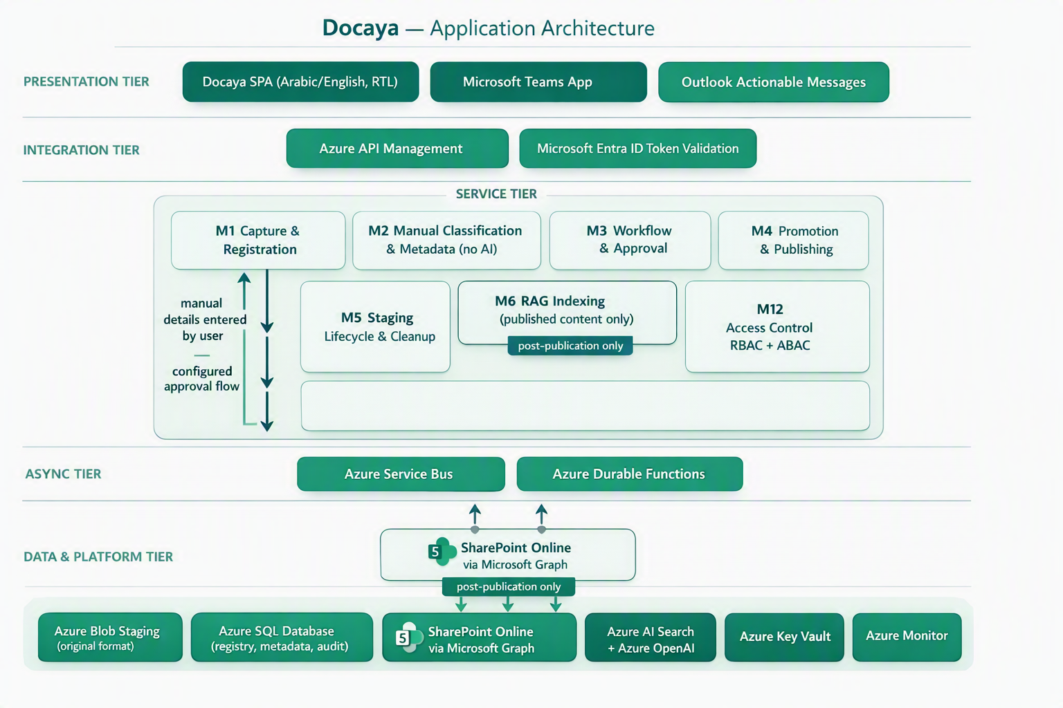
Figure 6 - Docaya application architecture: presentation, integration, service, asynchronous and data tiers across Azure and Microsoft 365.

23. Non-Functional & Compliance Targets
Attribute | Target
Availability | 99.9% baseline (higher tier by service design)
Page load | p95 < 1.5 seconds
Search latency | p95 < 400 ms (permission-trimmed)
Max file size | Up to 5 GB (resumable, chunked)
Recovery | RPO ≤ 5 minutes · RTO ≤ 1 hour
Accessibility | WCAG 2.2 AA; Arabic & English (RTL)
Data residency | UAE Azure regions only
Security | UAE IA standards, PDPL, ISO 27001 alignment; zero-trust, least privilege
Change-request SLA | Urgent: 12 working days end-to-end · Normal: 30 working days; extensions granted by Assurance only, with a recorded reason (Section 8.6)
Review-stage transparency | Stage-level duration captured automatically; at-risk and overdue alerts raised before the target date (Sections 8.6, 20.3)

24. Delivery Roadmap
Phase | Scope | Indicative timeline
MVP | UAE PASS SSO, capture→staging, classification, approval, promotion, versioning | Months 1–5
V1 | Notification Center, Admin Center, correspondence, search, reporting | Months 5–8
V2 | permission-trimmed metadata and full-text/source-text search, retention/legal hold, analytics, integrations | Months 9–12
- V1 scope (NEW addition) - configurable multi-level review chain, threaded comments, change-request SLA engine, and department/standard navigation are targeted for V1 alongside the Admin Center, since they extend the same modules (M3, M10, M13).
- V2 scope (NEW addition) - the four change-request Docaya native in-application reports and analytics (Section 20.3) are targeted for V2 alongside the existing analytics scope.

25. Assumptions, Decisions & Next Steps

25.1 Key Design Decisions
ID | Decision | Status
D1 | SharePoint Online remains the published system of record | Accepted
D2 | All content follows staging → classify → approve → promote | Accepted
D3 | UAE PASS federated to Entra ID is the primary SSO | Accepted
D4 | SharePoint accessed via one governed service identity; user access managed in Docaya | Accepted
D5 | metadata and full-text search delivered via a batch configured document processing workflow on Azure metadata and full-text search | Accepted
D6 | Azure SQL is the authoritative registry, audit and metadata store | Accepted
D7 | The approve/reject gate becomes a configurable 3–4-stage review chain (Editor → Owner/Approver → Assurance → Authoriser) | Proposed
D8 | Change-request SLA targets default to 12 working days (Urgent) and 30 working days (Normal), extendable only by Assurance with a recorded reason | Proposed

25.2 Immediate Next Steps
- Confirm the Client's document classes, sensitivity markings and departmental library map.
- Finalise UAE PASS ↔ Entra ID federation and the SharePoint service-identity permission scope.
- Approve the retention schedule and legal-hold policy with Records & Compliance.
- Configure the approval routing rules per class and sensitivity in the Admin Center.
- Stand up the upload-time extraction and search-data processing and validate permission-trimmed retrieval.
- Run an end-to-end pilot (capture → publish → search) with one department before rollout.
- Confirm the default 4-stage review chain and any department-specific variants.
- Confirm the working-day calendar (weekends and public holidays) used for the 12/30-day SLA targets.
- Confirm the department/standard taxonomy for navigation tabs.
- Review the four Docaya native in-application report layouts against the Client's procedure document once received.
Review outcome required Endorse the revised 9-step lifecycle, the manual classification model, the no-format-conversion promotion rule, the UAE PASS + service-identity integration, and the revalidated Azure/Microsoft reference architecture, together with the v2.1 review-chain, SLA and native analytics additions so build can proceed against this baseline.
- End of Document -

